Thanks for downloading 20 Logo Templates with customizable PSD vector sources.
If you like this asset, I will be grateful for your feedback: http://u3d.as/1XRD
If you have any suggestions or questions, you can write to this email: pirate.parrot.software@gmail.com
In this document you will find information on how to change each logo:
- You need to install photoshop.
- Some of the Fonts can be found in the Fonts folder, and some must be downloaded from the https://fontstorage.com/category/. After that, you need to install the required fonts on your PC. You can find information on how to do it on the Internet: "How to add a font to Photoshop Mac/Windows".
- Open the PSD file you need.
- In the Photoshop, via the Windows tab, turn on the Layers and Tools.
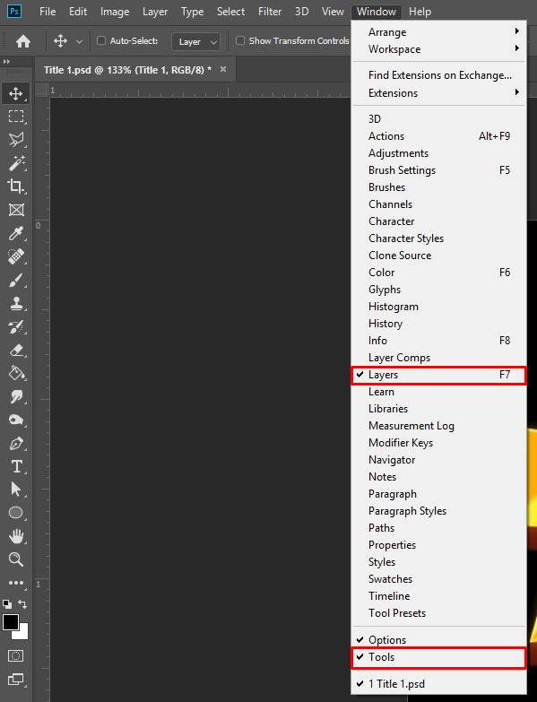
- To resize canvas, click Image - Canvas Size.
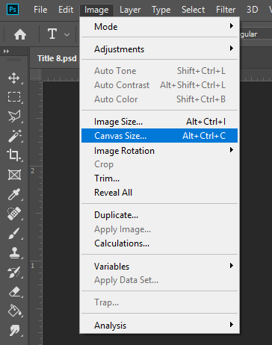
- Press Cmd + H (macOS), Ctrl + H (Windows) to turn guide lines on/off.
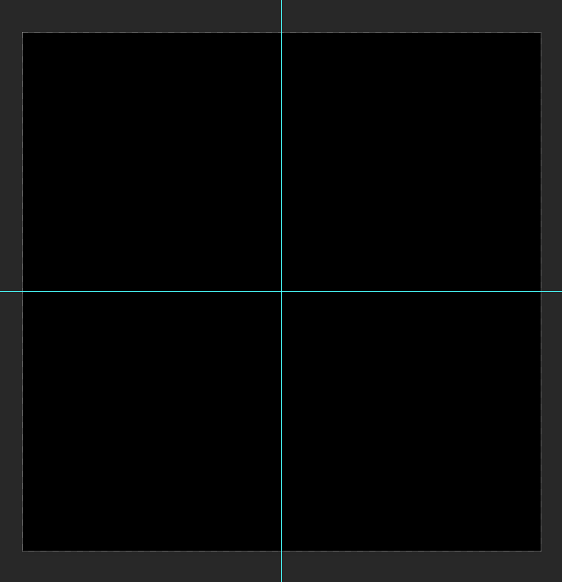

- Expand a group of files by clicking the arrow next to the Folder.
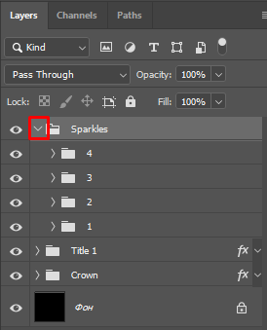
- To hide or show a layer by clicking on the eye next to the layer.
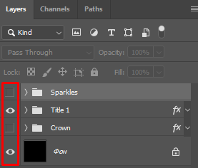
- To undo one or more actions, use the following commands: Cmd + Z (macOS), Ctrl + Z (Windows) or Cmd + Alt + Z (macOS), Ctrl + Alt + Z (Windows).

Title 1.psd – Royal Raffle
Font: peace sans

- Expand the Title 1 folder and change the text. To do this, press the (T) button or select the Text tool on the Toolbar. Then move your cursor over the text and change it.
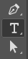
- You can adjust the gradient to match your text. To do this, right-click on the text layer and select "Blending Options..." and go to the "Gadient Overlay".

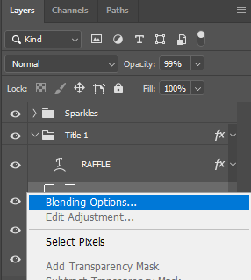 | 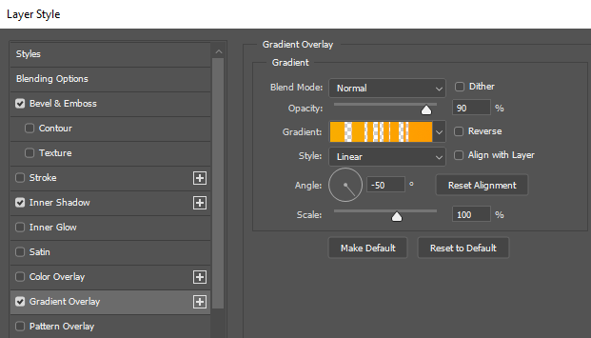

- Then, hold down left mouse button and move the cursor (left/right) on the canvas.
- The text is ready, it remains to move the Crown and Sparkles. To do this, , press the (V) key or select the Move tool on the Toolbar. After selecting the desired folder in the Layers tab, move the object on the canvas.
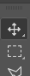

Title 2.psd – 1,000 coins
Font: gilam

- Expand the Title 2 folder and change the text. To do this, press the (T) button or select the Text tool on the Toolbar. Then move your cursor over the text and change it.

- The text is ready, you alson need to move the Sparkles. To do this, press the (V) key or select the Move tool on the Toolbar. After selecting the desired folder in the Layers tab, move the object on the canvas.


Title 3.psd – Turbo
Font: molot and fira sans heavy

- Expand the Title 3 folder and change the text. To do this, press the (T) button or select the Text tool on the Toolbar. Then move your cursor over the text and change it.

- You can adjust the gradient to match your text. To do this, right-click on the text layer and select "Blending Options..." and go to the "Gadient Overlay".

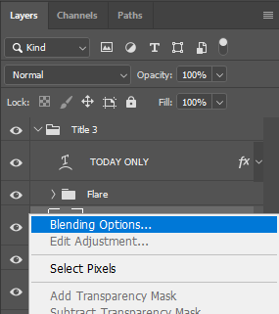 | 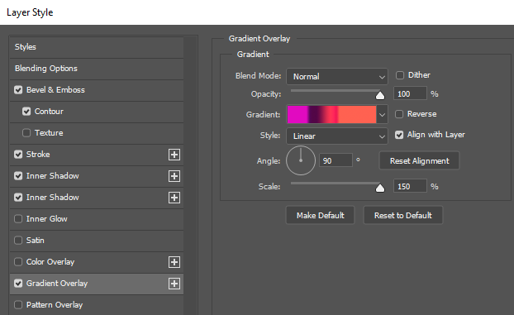

- Then, hold down the left mouse button and move the cursor (up/down) on the canvas.
- There is a Flare at the bottom of the each letter. To change them, expand the Flare folder and select one of the layers. Move this layer by pressing the (V) key or choosing the Move tool. If you need to change the size press the keyboard shortcut Cmd + T (macOS), Ctrl + T (Windows) and change it. To duplicate a layer, select the layer and press Cmd + J (macOS), Ctrl + J (Windows) or right-click on the layer and select Duplicate Layer.
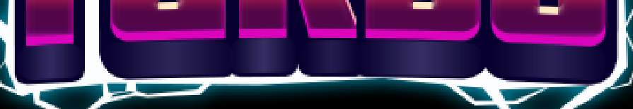

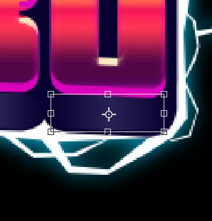
- The text is ready, only the lightning remains to be done. It won't be easy, but you can handle it! Open the Lightning folder and select Base Layer.
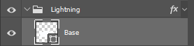
- Select the Pen tool from the panel. Start tracing your text casually with the Pen left-click.
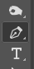
- Expand the Little lightning folder and move each layer as you need using the Move tool (V).
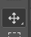
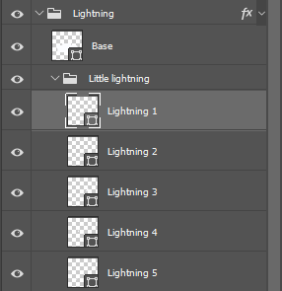
- To duplicate a layer, select the layer and press Cmd + J (macOS), Ctrl + J (Windows) or right-click on the layer and select Duplicate Layer.
- To change the size press the keyboard shortcut Cmd + T (macOS), Ctrl + T (Windows) and change it.

Title 4.psd – Wanted West
Font: chunkfive ex

- Expand the Wanted and West folders and change the text. To do this, press the (T) button or select the Text tool on the Toolbar. Then move your cursor over the text and change it.

- Hide layers with main text Wanted and West. Expand the Back folder and change the text on each layers to make it three-dimensional. Leave only one text layer visible so that the rest will not interfere with you.
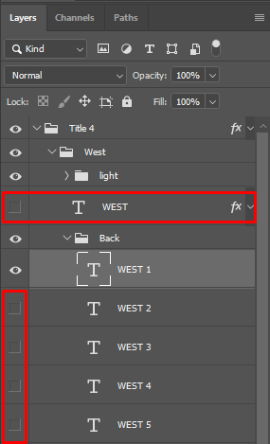
- Expand the Light folder, position the layers so that the Highlights are in the upper left corner of each letter of your text. Move this layer by pressing the (V) key or choosing the Move tool. If you need to change the size press the keyboard shortcut Cmd + T (macOS), Ctrl + T (Windows) and change it.

- To duplicate a layer, select the layer and press Cmd + J (macOS), Ctrl + J (Windows) or right-click on the layer and select Duplicate Layer.
- If you have holes between the letters in the text, you need to close them with the Pen Tool (P).
 | 


- Select the Back red or Back purple layer, hide it and start drawing a shape with the Pen Tool, which will cover the voids in the text (press the left mouse button).

Title 5.psd – Chicken Crazy Park
Font: fira sans heavy

- Expand the Title 5 folder and change the text. To do this, press the (T) button or select the Text tool on the Toolbar. Then move your cursor over the text and change it.

- Move the Egg folders as needed using the Move Tool (V).

- If you have holes between the letters in the text, you need to close them with the Pen Tool (P).
 | 


- Select Back layer, hide it and start drawing a shape with the Pen Tool, which will cover the voids in the text (press the left mouse button).

Title 6.psd – Android
Font: fira sans heavy

- Expand the Title 6 folder and change the text. To do this, press the (T) button or select the Text tool on the Toolbar. Then move your cursor over the text and change it.

- If you need to change the size press the keyboard shortcut Cmd + T (macOS), Ctrl + T (Windows) and change it.
- You can adjust the gradient to match your text. To do this, right-click on the text layer and select "Blending Options..." and go to the "Gadient Overlay".

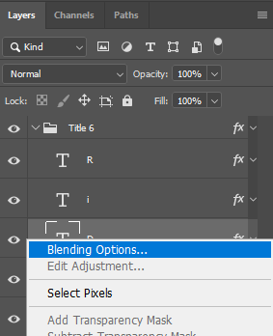 | 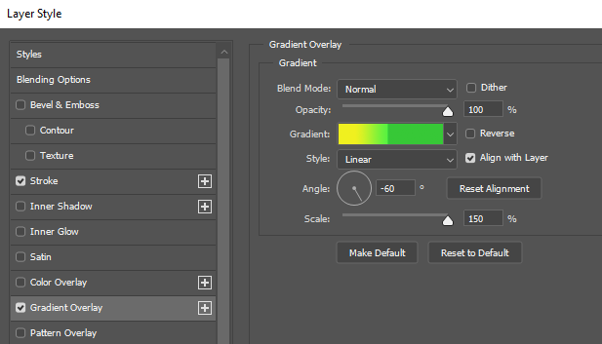

- Then, hold down the left mouse button and move the cursor (left/right) on the canvas.
- To change the Drop Shadow in each letter, set the same tilt for each item.
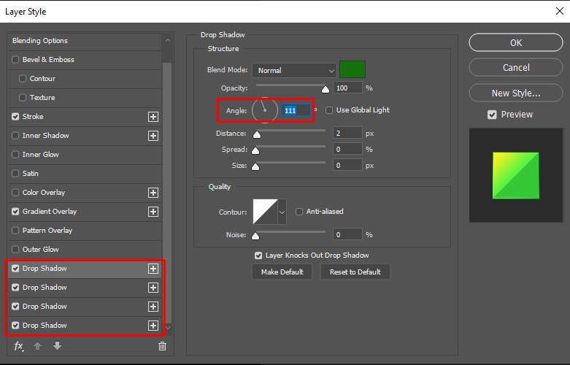

Title 7.psd – Sweet pack
Font: boomboom

- Expand the Title 7 folder and change the text. To do this, press the (T) button or select the Text tool on the Toolbar. Then move your cursor over the text and change it.
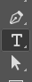
- You can adjust the gradient (on Pack text) or pattern (on Sweet text) to match your text. To do this, right-click on the text layer and select "Blending Options..." and go to the "Gadient Overlay" or "Pattern Overlay".

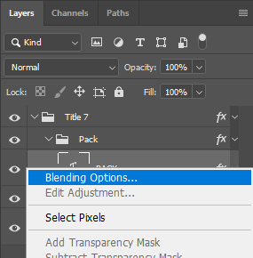 | 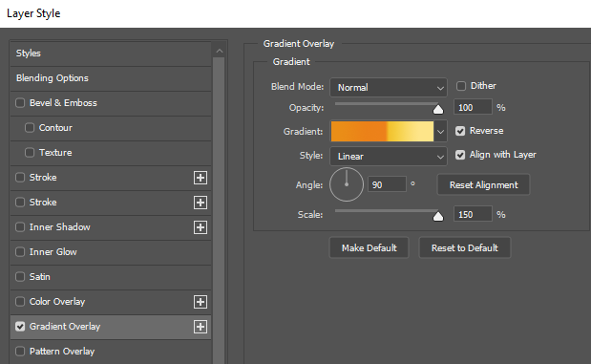
- Then, hold down the left mouse button and move the cursor on the canvas.

Title 8.psd – Frenzy Hotel
Font: peace sans

- Expand the Title 8 folder and change the text. To do this, press the (T) button or select the Text tool on the Toolbar. Then move your cursor over the text and change it.

- You can adjust the gradient to match your text. To do this, right-click on the text layer and select "Blending Options..." and go to the "Gadient Overlay".

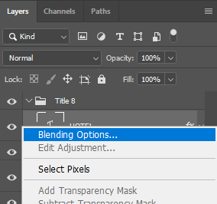 | 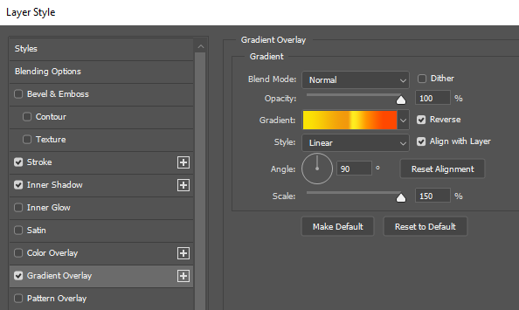

- Then, hold down the left mouse button and move the cursor (up/down) on the canvas.
- Hide layers with main text Frenzy and Hotel. Expand the Back Hotel or Back Frenzy folder and change the text on each layers to make it three-dimensional. Leave only one text layer visible so that the rest will not interfere with you.
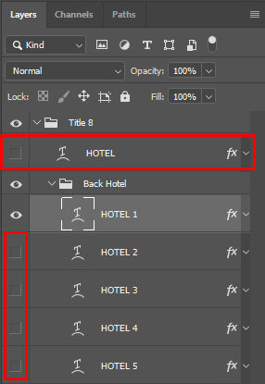
- To change the size press the keyboard shortcut Cmd + T (macOS), Ctrl + T (Windows) and change it.
- Move layers by pressing the (V) key or choosing the Move tool.


Title 9.psd – Ready Set Go!
Font: fira sans heavy

- Expand the Title 9 folder and change the text. To do this, press the (T) button or select the Text tool on the Toolbar. Then move your cursor over the text and change it.

- You can adjust the gradient to match your text. To do this, right-click on the text layer and select "Blending Options..." and go to the "Gadient Overlay".

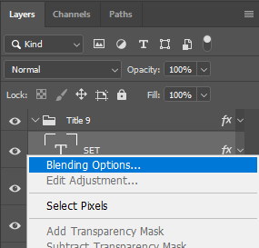 | 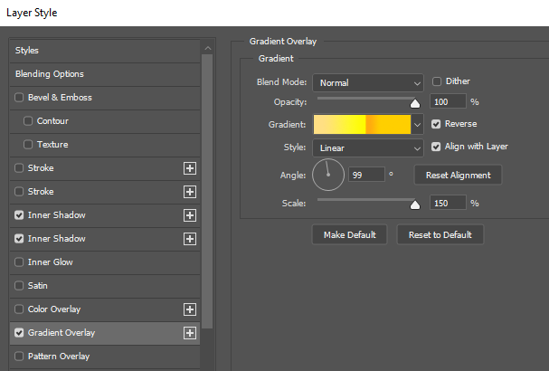

- Then, hold down the left mouse button and move the cursor (up/down) on the canvas.

- If you have holes between the letters in the text, you need to close them with the Rectangle Tool (U).
 | 

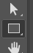
- Select Back 1 layer, hide it and start drawing a shape with the Rectangle Tool, which will cover the voids in the text.

Title 10.psd – Crazy Planet
Font: foo

- Expand the Title 10 folder and change the text. To do this, press the (T) button or select the Text tool on the Toolbar. Then move your cursor over the text and change it.

- You can adjust the pattern to match your text. To do this, right-click on the text layer and select "Blending Options..." and go to the "Pattern Overlay".

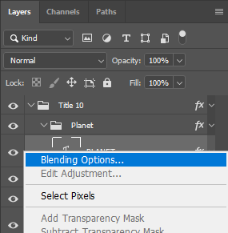 | 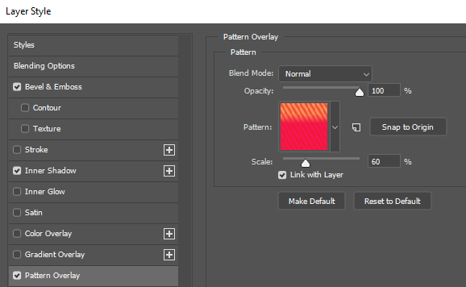
- Then, hold down the left mouse button and move the cursor on the canvas.
- Hide layers with main text Crazy and Planet. Expand the Back folder and change the text on each layers to make it three-dimensional. Leave only one text layer visible so that the rest will not interfere with you.
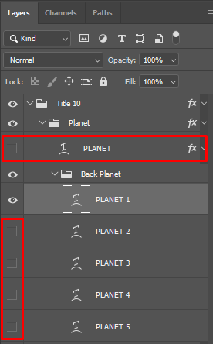
- If you have holes between the letters in the text, you need to close them with the Pen Tool (P).
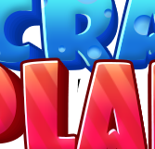 | 


- Select White back layer, hide it and start drawing a shape with the Pen Tool, which will cover the voids in the text (press the left mouse button).

Title 11.psd – Crystal Rush
Font: peace sans

- Expand the Title 10 folder and change the text. To do this, press the (T) button or select the Text tool on the Toolbar. Then move your cursor over the text and change it.

- Hide layer with main text Crystal. Expand the Back Crystal folder and change the text on each layers to make it three-dimensional. Leave only one text layer visible so that the rest will not interfere with you.
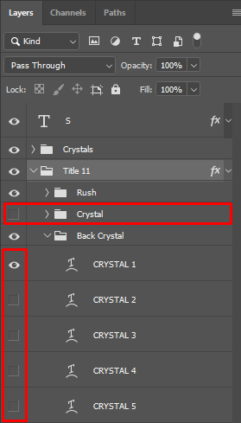
- Move Gem folder by pressing the (V) key or choosing the Move tool.

- If you have holes between the letters in the text, you need to close them with the Pen Tool (P).
 | 


- Select Back layer, hide it and start drawing a shape with the Pen Tool, which will cover the voids in the text (press the left mouse button).
- You can adjust the gradient to match your text. To do this, right-click on the text layer and select "Blending Options..." and go to the "Gadient Overlay".

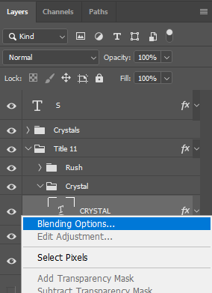 | 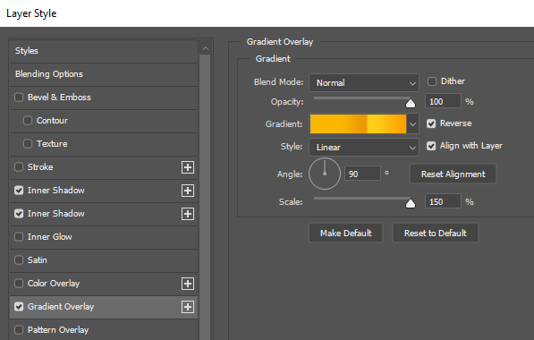

- Then, hold down the left mouse button and move the cursor (up/down) on the canvas.

Title 12.psd – Invite Friends Mania
Font: asket condensed and peace sans

- Expand the MANIA and INVITE FRIENDS folders and change the text. To do this, press the (T) button or select the Text tool on the Toolbar. Then move your cursor over the text and change it.

- Hide layers with main text MANIA and INVITE FRIENDS. Expand the Back folder and change the text on each layers to make it three-dimensional. Leave only one text layer visible so that the rest will not interfere with you.
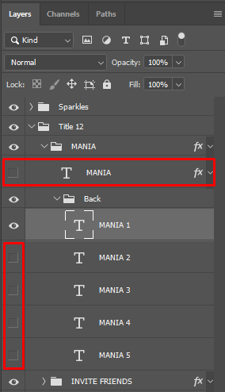
- To get a nice stroke in this text, you will need to make copies of the MANIA and INVITE FRIENDS folders. Select the folders and press Cmd + J (macOS), Ctrl + J (Windows) or right-click on the folder and select Duplicate Group.
- Move these two new duplicate text folders to the Border folder. Select them with the mouse in the Layers panel and drag them. Next, select them and right-click, select Clear Layer Style from the list.
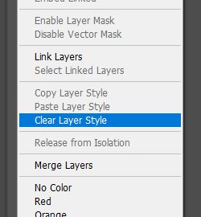
- If you have holes between the letters in the text, you need to close them with the Pen Tool (P).
 | 


- Select White back layer, hide it and start drawing a shape with the Rectangle Tool, which will cover the voids in the text (The rectangle should be above the folders with a copy of your text).
- Move Sparkles by pressing the (V) key or choosing the Move tool.


Title 13.psd – Building Flash
Font: asket condensed

- Expand the Title 13 folder and change the text. To do this, press the (T) button or select the Text tool on the Toolbar. Then move your cursor over the text and change it.

- To change the text on the building Reflection layer, hide the two main text layers (flash and building) by clicking on the eye next to them.
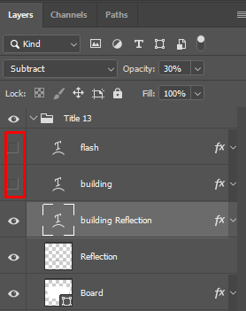
- To make a Reflection for the bottom text, you need to perform several steps. Duplicate the bottom text layer, press Cmd + J (macOS), Ctrl + J (Windows) or right-click on the layer and select Duplicate Layer. Press the keyboard shortcut Cmd + T (macOS), Ctrl + T (Windows). On the canvas, right-click and select Flip Vertical. Press Enter.
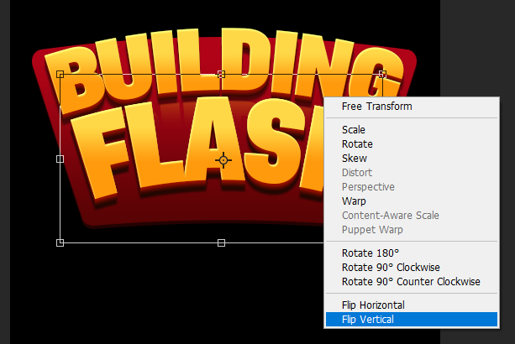
- Using the Move tool by pressing the (V) key or choosing the Move tool, place a copy of the text below the body text.

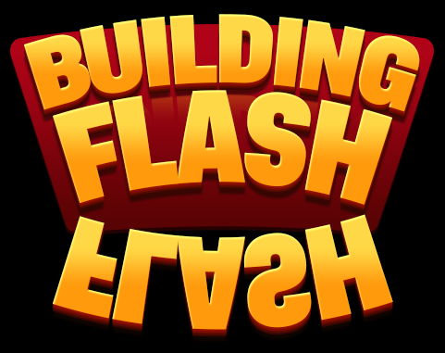
- If after the 3) point, the text has changed its appearance, click the buttons (T), and next:
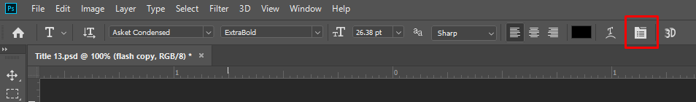
- Turn the All caps button off and on again.
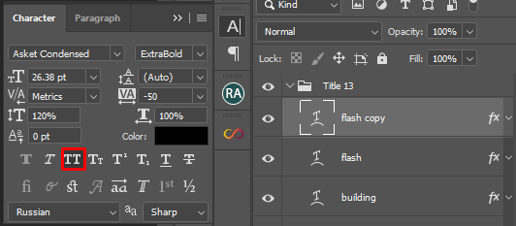
- Let's change the curvature of the text.
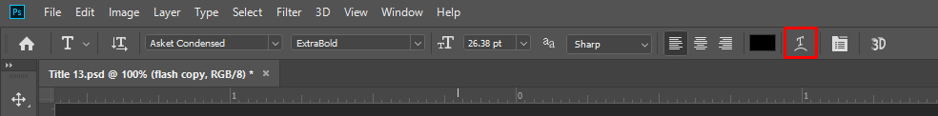
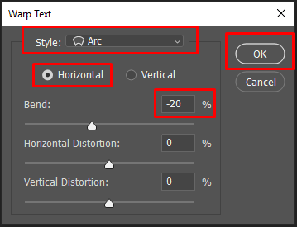
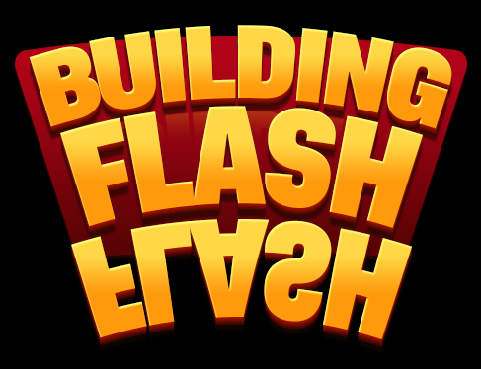
- Reduce the size of the copy of the text so that it matches the body text and Move tool it by pressing the (V) key or choosing the Move tool.
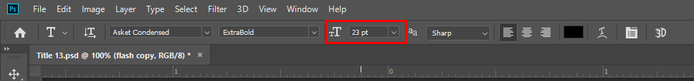
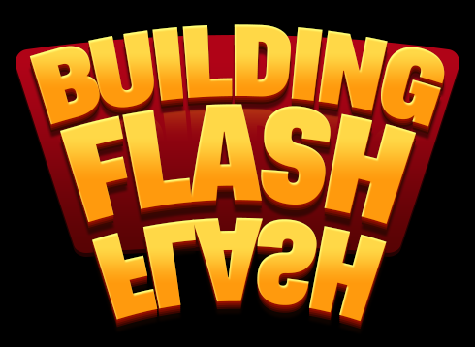
- Right-click on the text copy layer in the Layers panel, click Rasterize Layer Style.
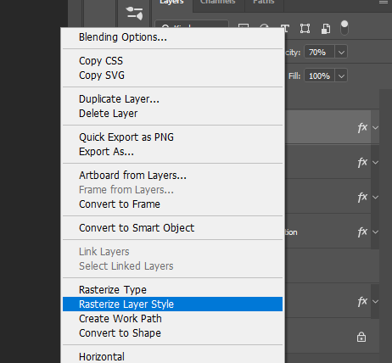
- For the copy of the text in the Layers panel, change the Blending Mode and Opacity. You can temporarily set a higher Opacity percentage to better see the text you are working with.
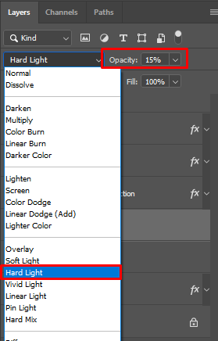
- Hold the Cmd (macOS), Ctrl (Windows), and hover over the Board layer in the Layers panel. While hovering over the Board layer thumbnail, the cursor will change to a hand with a rectangular selection. So you will make a selection on the board, then you need to invert the selection, press Cmd + I (macOS), Ctrl + I (Windows). And click the Delete button to erase the part of the text that extends beyond the board.
- Remove selection: Cmd + D (macOS), Ctrl + D (Windows).
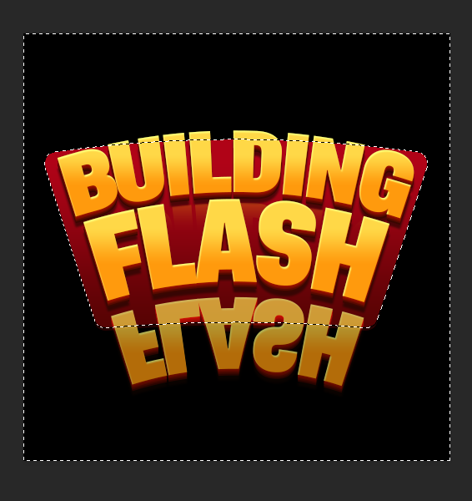 | 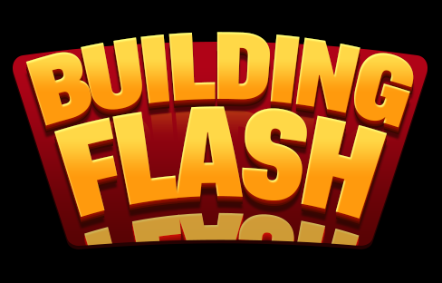
- Select the Erase Tool (E), a soft brush, set the size to whatever you want and erase the text a little bit more.
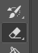

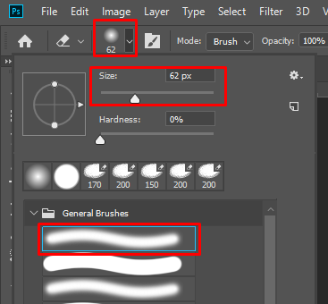
- Let's blur the Reflection a little.
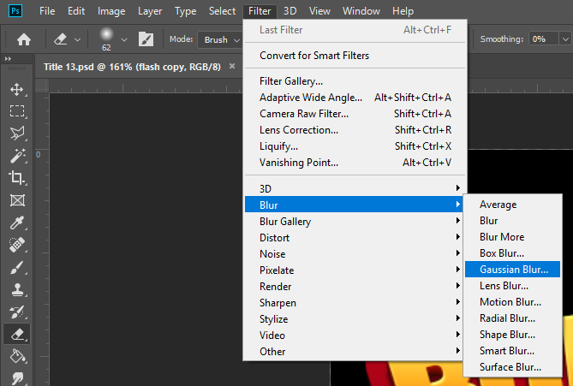
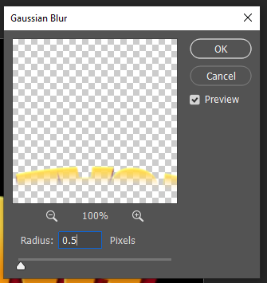

Title 14.psd – Cats Dreams
Font: peace sans and kaushan script

- Expand the Title 14 folder and change the text. To do this, press the (T) button or select the Text tool on the Toolbar. Then move your cursor over the text and change it.

- You can adjust the gradient to match your text. To do this, right-click on the text layer and select "Blending Options..." and go to the "Gadient Overlay".

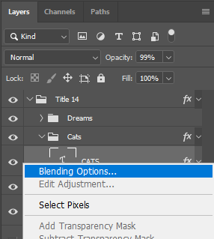 | 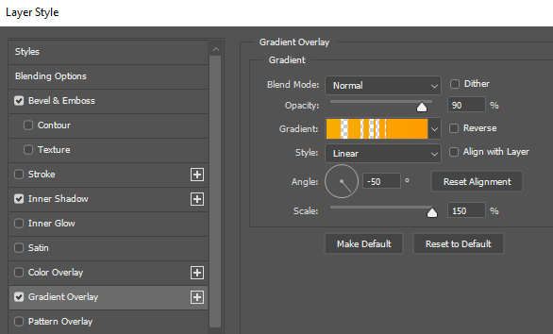

- Then, hold down the left mouse button and move the cursor (up/down) on the canvas.
- Move Crown by pressing the (V) key or choosing the Move tool. If you need to change the size press the keyboard shortcut Cmd + T (macOS), Ctrl + T (Windows) and change it.


- If you have holes between the letters in the text, you need to close them with the Pen Tool (P).
 | 


- Select White back layer, hide it and start drawing a shape with the Pen Tool, which will cover the voids in the text (press the left mouse button).

Title 15.psd – American Deal
Font: fira sans heavy

- Expand the Title 15 folder and change the text. To do this, press the (T) button or select the Text tool on the Toolbar. Then move your cursor over the text and change it.

- Hide layer with main text DEAL. Expand the Back folder and change the text on each layers to make it three-dimensional. Leave only one text layer visible so that the rest will not interfere with you.
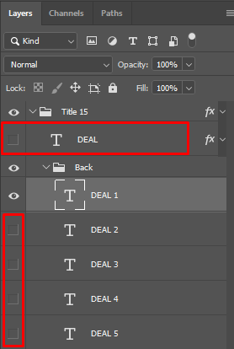
- If you need to move the Pattern (USA Flag), right-click on the text layer and select "Blending Options..." and go to the "Pattern Overlay".
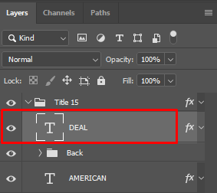
 | 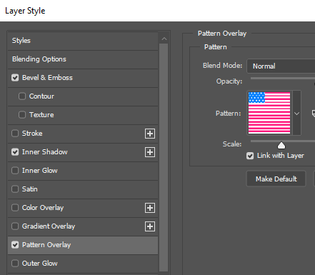

- Then, hold down the left mouse button and move the cursor on the canvas.

Title 16.psd – Bird Party
Font: peace sans
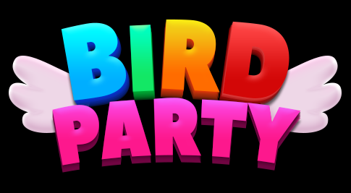
- Expand the Title 16 folder and change the text. To do this, press the (T) button or select the Text tool on the Toolbar. Then move your cursor over the text and change it.

- Move Wings by pressing the (V) key or choosing the Move tool. If you need to change the size press the keyboard shortcut Cmd + T (macOS), Ctrl + T (Windows) and change it.


Title 17.psd – Tangled Yellow Road
Font: fira sans heavy

- Expand the Title 17 folder and change the text. To do this, press the (T) button or select the Text tool on the Toolbar. Then move your cursor over the text and change it.

- If you have holes between the letters in the text, you need to close them with the Pen Tool (P).
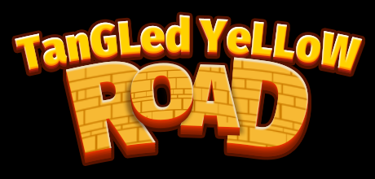 | 


- Select Back layer, hide it and start drawing a shape with the Pen Tool, which will cover the voids in the text (press the left mouse button).
- If you need to move the Pattern (Bricks), right-click on the text layer and select "Blending Options..." and go to the "Pattern Overlay".
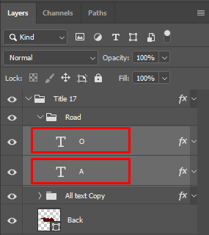
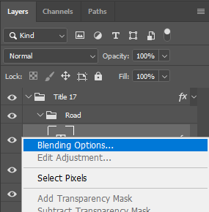 | 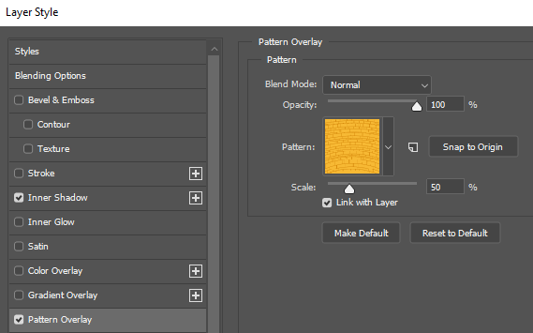

- Then, hold down the left mouse button and move the cursor on the canvas.

Title 18.psd – Galaxy Game
Font: foo and fira sans heavy

- Expand the Title 18 folder and change the text. To do this, press the (T) button or select the Text tool on the Toolbar. Then move your cursor over the text and change it.

- If you have holes between the letters in the text, you need to close them with the Pen Tool (P).
 | 


- Select White back layer, hide it and start drawing a shape with the Pen Tool, which will cover the voids in the text (press the left mouse button).

Title 19.psd – Girl Dreams
Font: fira sans heavy

- Expand the Title 19 folder and change the text. To do this, press the (T) button or select the Text tool on the Toolbar. Then move your cursor over the text and change it.

- Hide layers with main text GIRL and DREAMS. Expand the Back folder and change the text on each layers to make it three-dimensional. Leave only one text layer visible so that the rest will not interfere with you.
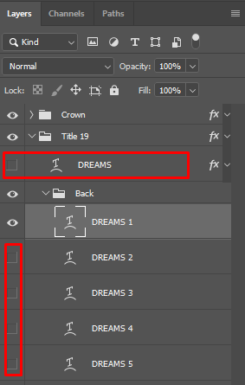
- Move Crown by pressing the (V) key or choosing the Move tool. If you need to change the size press the keyboard shortcut Cmd + T (macOS), Ctrl + T (Windows) and change it.

Title 20.psd – Building Blast
Font: peace sans

- Expand the Title 20 folder and change the text. To do this, press the (T) button or select the Text tool on the Toolbar. Then move your cursor over the text and change it.

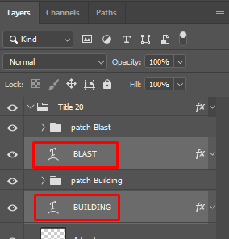
- In the Patch folders, you will find layers with shapes of different shapes that look like metal patches. Select folder that belong to a particular letter to move, duplicate or resize.
- Move layers by pressing the (V) key or choosing the Move tool. If you need to change the size press the keyboard shortcut Cmd + T (macOS), Ctrl + T (Windows) and change it.

- Duplicate the layer, press Cmd + J (macOS), Ctrl + J (Windows) or right-click on the layer and select Duplicate Layer.
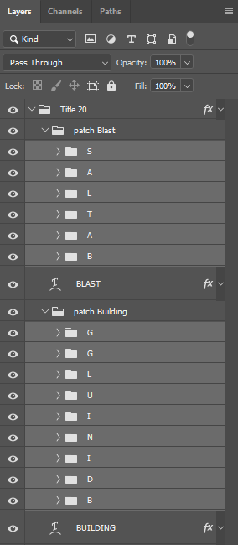
- If you have holes between the letters in the text, you need to close them with the Pen Tool (P).
 | 


- Select White back layer, hide it and start drawing a shape with the Pen Tool, which will cover the voids in the text (press the left mouse button). In the same way, I filled spaces in the letters, four layers called B back, A back, G back and D back.

Thanks for downloading 20 Logo Templates with customizable PSD vector sources.
If you like this asset, I will be grateful for your feedback: http://u3d.as/1XRD
If you have any suggestions or questions, you can write to this email: pirate.parrot.software@gmail.com

